McIntyre Fitness Application
John McIntyre
CST-451
Scott Webster
4/22/2026

Abstract
McIntyre Fitness is a desktop application that helps users track their workouts, monitor their progress, and manage their fitness goals. This Architectural Plan takes the basic ideas from earlier project phases and turns them into a more detailed design for how the system will be built. The application will be developed using C# and the .NET Framework, with MySQL used to store data. This document explains how the system will be structured, including the user interface design, database setup, and basic security features, so it can be used as a guide during development.

07/19/2026 - John McIntyre – Final Update: Billing feature removed from scope. All planned features implemented in CST-452 including password hashing, UI redesign, progress chart, date filter, logout, and motivational messages.
Professor Feedback: Said that I was on track and had a solid roadmap!

Final Technical Requirements
Requirement | Description | Software/Hardware
Development Environment | Development Environment (IDE) to write, debug, and test C# code. | Visual Studio
Data Storage | Database used to store user profile and exercise data. | MySQL and phpMyAdmin
Application Framework | A set of libraries to manage the GUI, database connectivity, and application features. | .NET Framework
Version Control | A system to track code changes and maintain project history. | GitHub
Operating System | The primary environment where the application is developed and intended to run. | Windows 11
Database Encryption | The method used to secure sensitive user information like passwords and billing data. | C# Crypto Libraries
Report Rendering | The capability to transform data into visual progress charts for the user | System.Windows.Forms.DataVisualization
Data Connectivity | The software driver required for the C# application to communicate with the MySQL database. | MySQL Connector/NET

Design Planning Summary
Project Overview: McIntyre Fitness is a desktop application designed for Windows 11 that uses C# and the .NET Framework. The main goal of the project is to provide people with a straightforward way to track their gym workouts and health progress in a single location.
Synopsis of Need: Many people struggle to stay consistent with their fitness because their information is scattered in too many places. Some people use physical notebooks while others use various phone apps or just try to remember their progress in their head. This creates a real need for a simple program where a user can own their data locally on their own computer. This approach is better because it means the user does not have to worry about having a stable internet connection or trusting a third party cloud service with their information.
Issues to Solve: The biggest issues this project aims to solve are the lack of clear progress tracking and growing concerns about digital privacy. Right now it is difficult for many people to actually see how they are improving over time. Additionally many people feel uncomfortable entering personal details or billing information into random websites. This application fixes those problems by keeping everything secure and stored on the user's local machine.
Proposed Solution: The proposed solution is a C# application that connects to a MySQL database to create a central hub. In this hub users can log their exercises, check their billing history, and look at charts that visualize their progress. Using a database allows the app to store a long history of workouts without the performance slowing down over time.
Rationale: I chose to build this for Windows 11 with the .NET Framework because it is a reliable combination that runs quickly on most computers. I also decided to use MySQL for the database because it is very good at organizing information which makes it much easier to generate accurate reports and progress charts for the user.

Overview of Design Concepts
High Level Design Narrative: The McIntyre Fitness application is designed to be very simple so that users can get in, log their workout, and get out without any confusion. The software is organized into three main layers. First is the user interface where the person interacts with buttons and forms. Second is the logic layer that handles the math for progress tracking and security. Third is the database layer where all the workout and profile data are stored on the local computer. This structure keeps the application fast and reliable because each part has a specific job to do.

User Interface Mockups: The following images show the planned design for the application. These screens include the login page for security, the main dashboard for navigation, and the specific forms for logging exercises and viewing billing history.

Log Workout
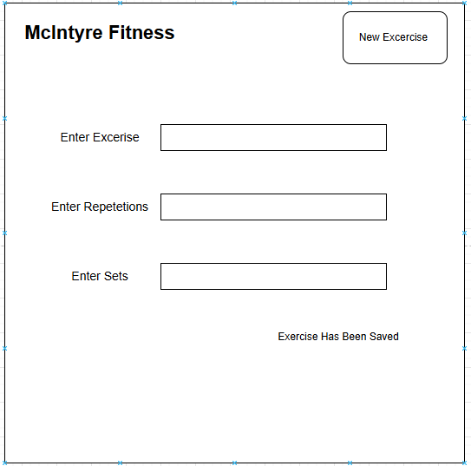

Edit / Delete Workout
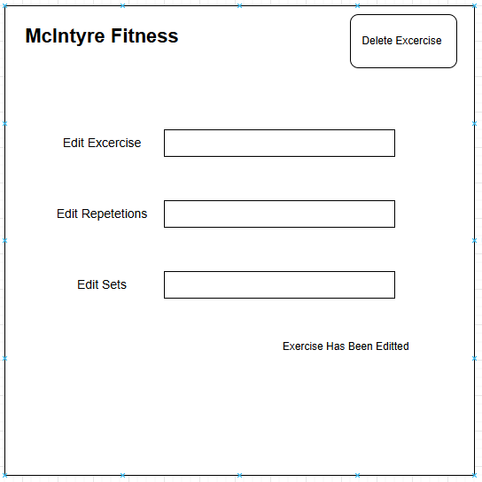

View Workout History
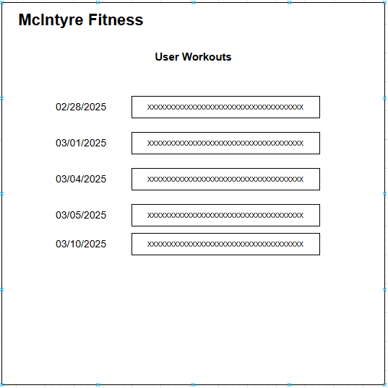

View Progress / Notifications
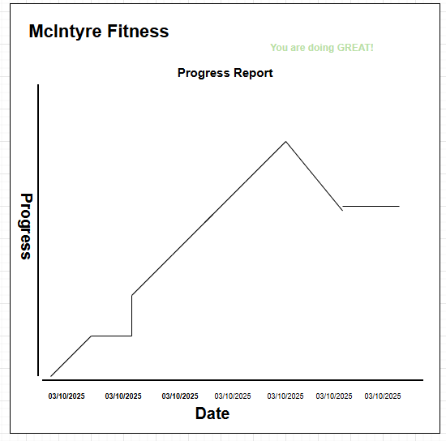

View Billing Data
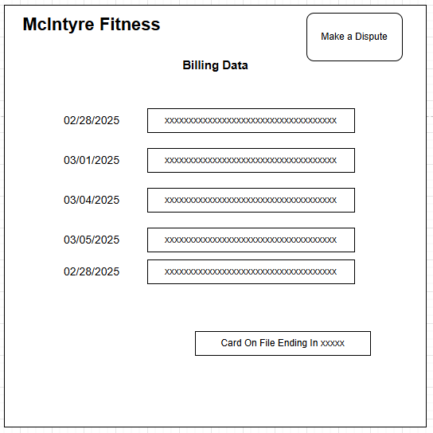

Sitemap
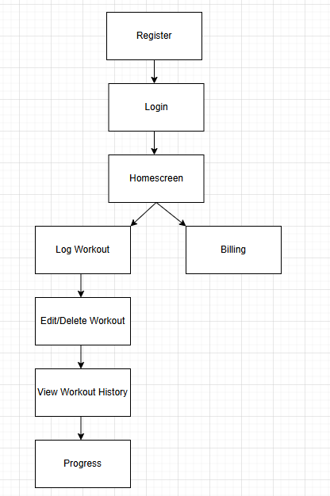

Program Logic and Process Flow
The most important part of the app is how it handles a user saving a workout. To make sure the data is accurate and saved correctly the program follows a specific path. First the user opens the Log Workout form and enters their exercise details like the name of the lift and how many reps they did. When the user clicks the save button the program checks to see if any of the boxes are empty. If a box is empty the program shows a clear error message telling the user to fill it out. If the boxes are all filled in correctly the program creates a secure connection to the MySQL database. The program then takes the exercise name and the numbers for reps and sets and sends them to the database. Once the database confirms that the information was saved the program shows a success message to the user. Finally the program clears the form so the user can enter another exercise without having to manually delete their old text.

Anticipated Process Flow
The typical way a person will use this app starts with the login screen for security. After they are authenticated they are taken to the home dashboard which acts as the main hub. From there the user will usually go to the workout logging section to enter their daily activity. Once they are done they can visit the progress section to see charts and tables that show how their strength has increased over time. When they are finished they can simply close the app and know that their data is safely stored in their local database without needing an internet connection.
Personal Statement and Explanation
Since I am the primary developer and the person responsible for the project requirements I have reviewed these design concepts and found them to be satisfactory. The mockups and the logic flow represent a complete solution that meets the goals of the project. I believe this design is ready for implementation because it covers all the necessary features like tracking workouts and showing progress while keeping the data secure on a local machine.

Detailed Solution Architecture
1. Project Structure Overview
The McIntyre Fitness app uses a three-layer setup to keep things organized. The top layer is the Windows interface where users click buttons and see their charts. The middle layer is the C# logic that handles the "math" and makes sure data is correct before it gets saved. The bottom layer is the MySQL database that physically holds the files on the computer. This design is great because it keeps the visual parts separate from the data storage, making the app faster and easier to fix if something goes wrong.

2. Object and Data Element Definitions
User Object: This object manages account security and identity. Its purpose is to verify who is using the app and keep their information separate from others. The data elements include a unique ID number for the user along with their username and a hashed password for security.
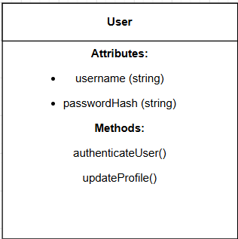
Workout Object: This is the core object used for tracking gym activity. Its purpose is to store the details of every exercise performed so the user can see their history later. The data elements include the name of the exercise and the numbers for repetitions and sets plus the date the workout was completed.
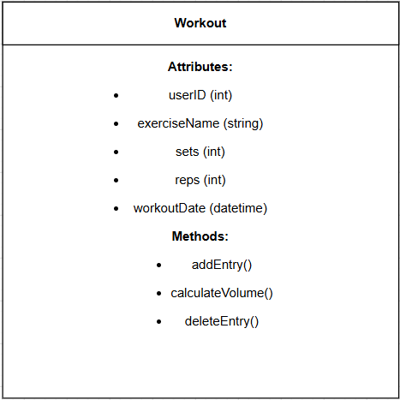
Billing Object: This object handles the financial records for the account. Its purpose is to show the user a history of their payments without exposing sensitive details. The data elements consist of the payment date and the total amount paid and a masked version of the credit card number that only shows the last four digits.
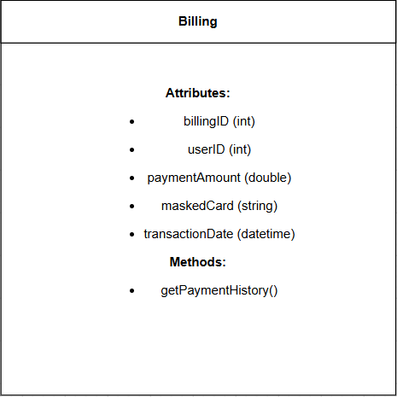
3. Additional Diagrams
Database Schema:
Users
Field Name | Data Type | Key Type
UserID | Integer | Primary Key
Username | VarChar (50)
PasswordHash | VarChar (255)

Workouts
Field Name | Data Type | Key Type
WorkoutID | Integer | Primary Key
UserID | Integer | Foreign Key
ExerciseName | VarChar (100)
Sets | Integer
Reps | Integer
Weight | Decimal
WorkoutDate | DateTime

Billing
Field Name | Data Type | Key Type
BillingID | Integer | Primary Key
UserID | Integer | Foreign Key
PaymentAmount | Decimal
MaskedCard | VarChar (20)
TransactionDate | DateTime

ER Diagram:
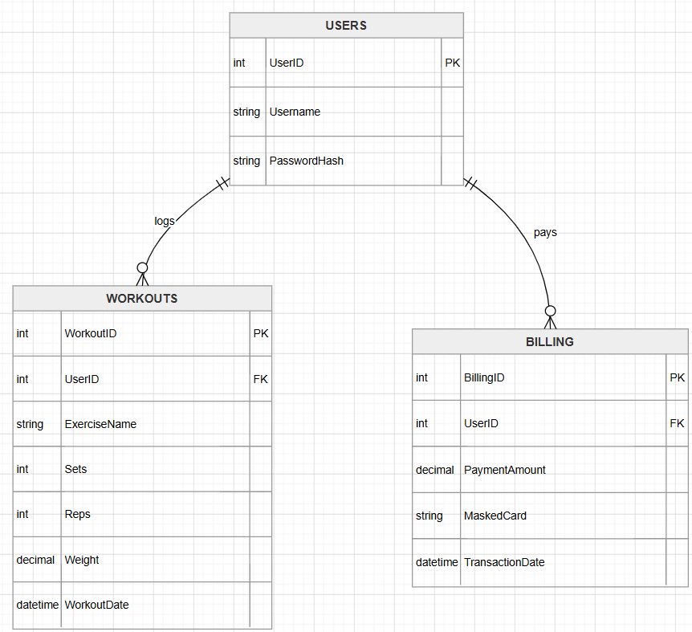

4. Sequence Diagram
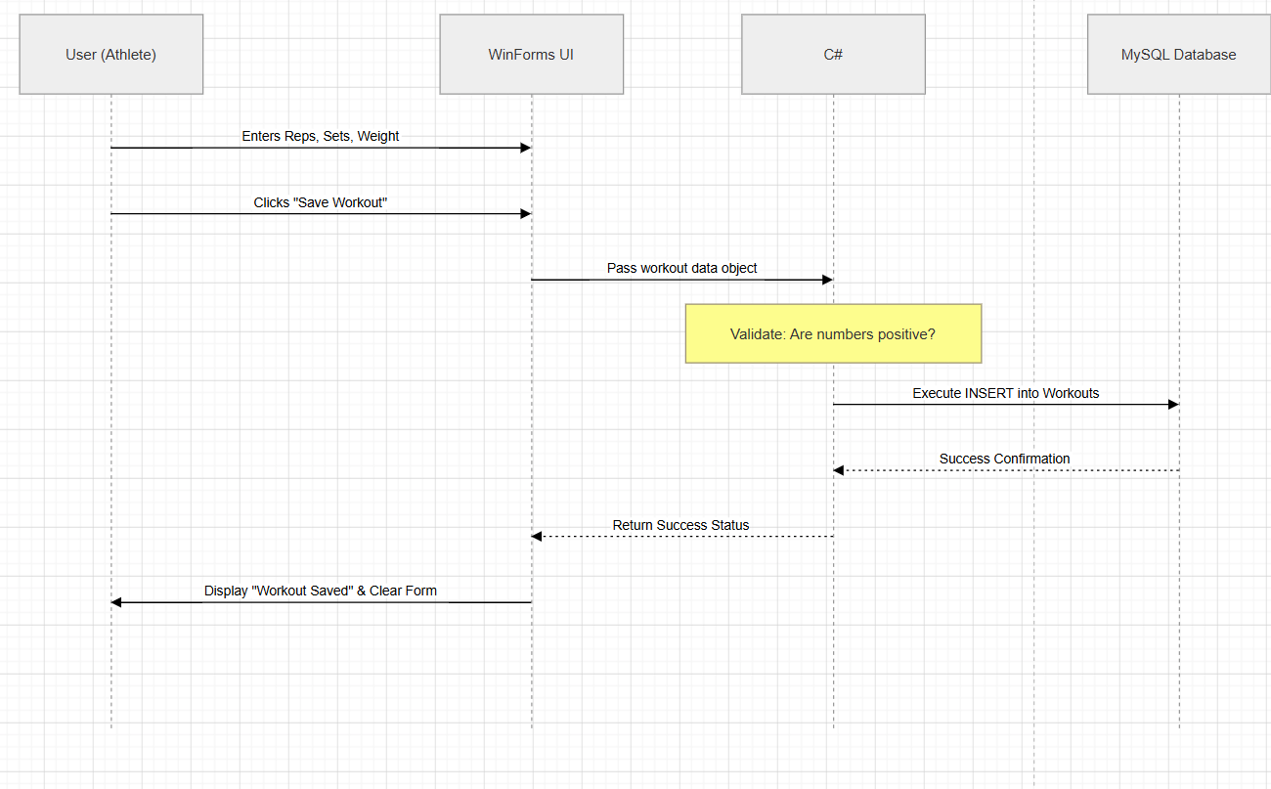
5. Algorithm Descriptions
The app uses a volume calculation to help users track their actual physical progress over time. Instead of just looking at the weight on the bar, this algorithm multiplies the sets, reps, and weight lifted to find the total workload for each session (Total Volume = Sets * Reps * Weight). This provides a single, clear metric that shows if a user is getting stronger or doing more work than in previous weeks. Additionally, the system uses a hashing algorithm for security. This process scrambles user passwords into a unique string of characters before they are saved to the database, ensuring that sensitive login information is never stored as plain text.

6. Detailed Specifications
The app uses a login screen to verify users and a main entry screen where they log their sets and reps and weight for each exercise. All this information is sent through a C# logic layer that connects directly to a MySQL database to keep everything organized and secure. When a user saves a lift the system automatically runs the volume math and updates the history report screen so they can see their progress immediately. Since everything is built from scratch for this project I don't have to worry about changing any other existing systems or software. The integration is handled through standard SQL connections that make sure the data conversion from the user input to the database records happens without any errors or lost info.

7. Configuration Changes
To get the project running, a basic laptop or desktop with 8GB of RAM is enough to handle the development tools without lagging. The software setup includes Visual Studio for the C# coding and MySQL Workbench to manage the database tables. I also need the .NET SDK installed so the backend logic works correctly. The main configuration change is setting up the connection strings in the code so it can find the local MySQL server. Since this is a local setup for development on a desktop application, there isn't any need for expensive server hardware or complex networking changes.

8. System Security
To keep the system secure I am mostly focusing on protecting user data and preventing common database attacks. I’m not going to store any plain text passwords in the database and instead I’ll use a hashing algorithm to scramble them. This way if the database ever got leaked the actual passwords would stay hidden. I’m also planning to use parameterized queries in my C# code to stop SQL injection which is when someone tries to send malicious commands through the input fields. For resources I'm just using the standard security tools that come with the .NET framework to handle the encryption logic so I don't have to worry about adding a bunch of extra software.

Sign Off
Version | Date | Author | Description of Change | Reason for Change | Signature
1.0 | 04/10/2026 | John McIntyre | Initial draft | Project start
1.1 | 04/20/2026 | John McIntyre | Added diagrams | Section 4 requirements
1.2 | 04/26/2026 | John McIntyre | Updated security | Added hashing logic

